Treatment guideline module – SafeBoosC-IIIv

Learning objectives

Welcome to the training module on the SafeBoosC treatment guideline. In this module you will be introduced to the most important aspects of the treatment guideline and related pathophysiology. By the end of this module, we hope you will be able to:
- Understand the pathophysiology of transitional circulation and the circulatory side-effects of mechanical ventilation
- Understand the causes of low rStO2, relevant clinical assessment, and interventions to restore rStO2 within normal range
- Understand the role of rStO2 in decision making
- Understand the challenges that may appear during the conduct of SafeBoosC-IIIv

- Pathophysiology of transitional circulation

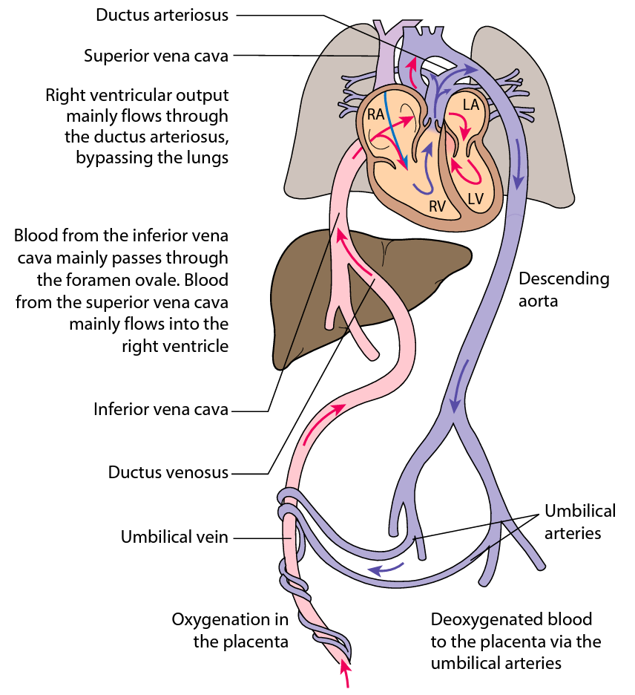
Figure 1. Foetal circulation

Soon after an infant is born there is a rise in systemic vascular resistance (SVR), a decrease in pulmonary vascular resistance, and the cardiac output (CO) is distributed in parallel. Progressively, the foetal channels foramen oval and ductus arteriosus close.
Hypoxia, hypercapnia, acidosis, and inflammation may cause the pulmonary vascular resistance to increase again to produce a state of ‘foetal circulation’ with right-to-left shunting, poor filling of the left side of the hearth and low cardiac output.

The immature cardiovascular system frequently fails to adapt to birth. This is due to the limited myocardial contractility of the immature heart, and a potentially compromised preload due to poor diastolic function and lung inflation (Fig. 2). This may lead to decreased CO and abnormal blood flow distribution, particularly in the less mature and sick infants.

Decreased blood flow to the brain (CBF) and oxygen delivery to the brain may be the consequence.
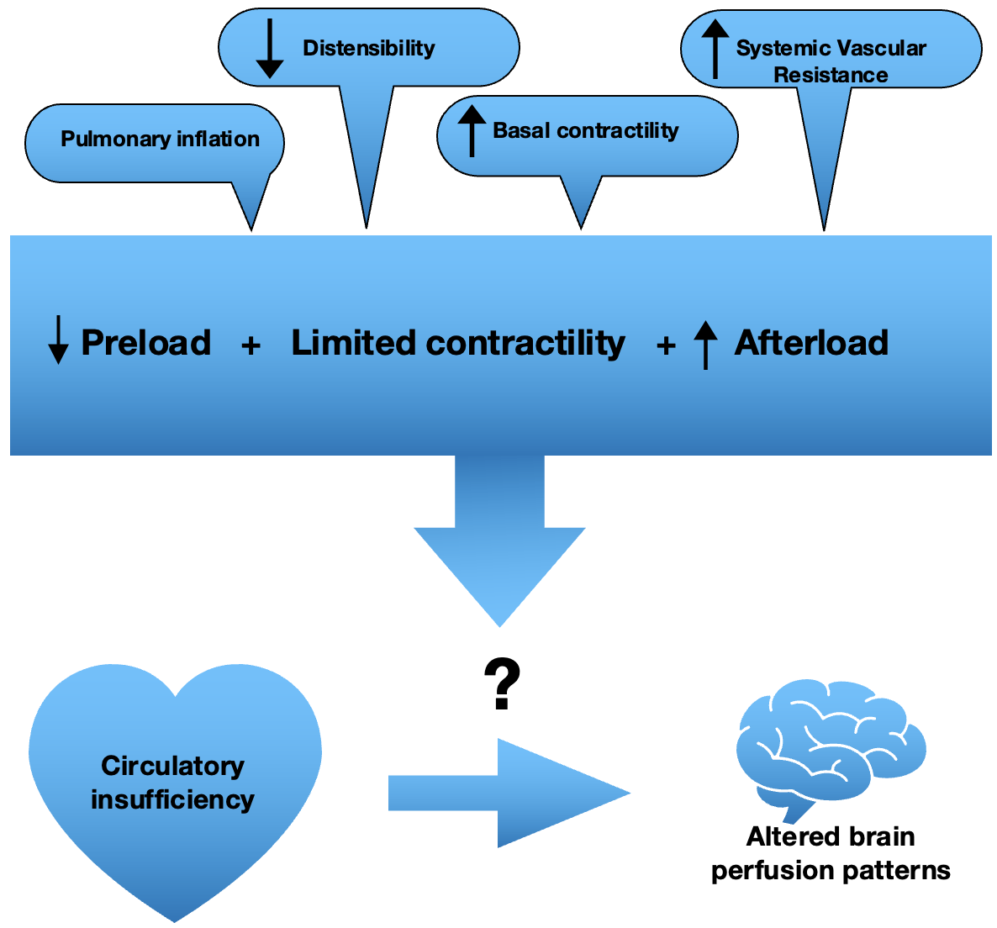

Figure 2. Pathophysiology of cardiovascular failure soon after birth in the most premature neonates.

Blood flow, oxygen transport, and cellular metabolism are interdependent. Several aspects should be considered when evaluating the haemodynamic condition of an infant (Fig. 3).

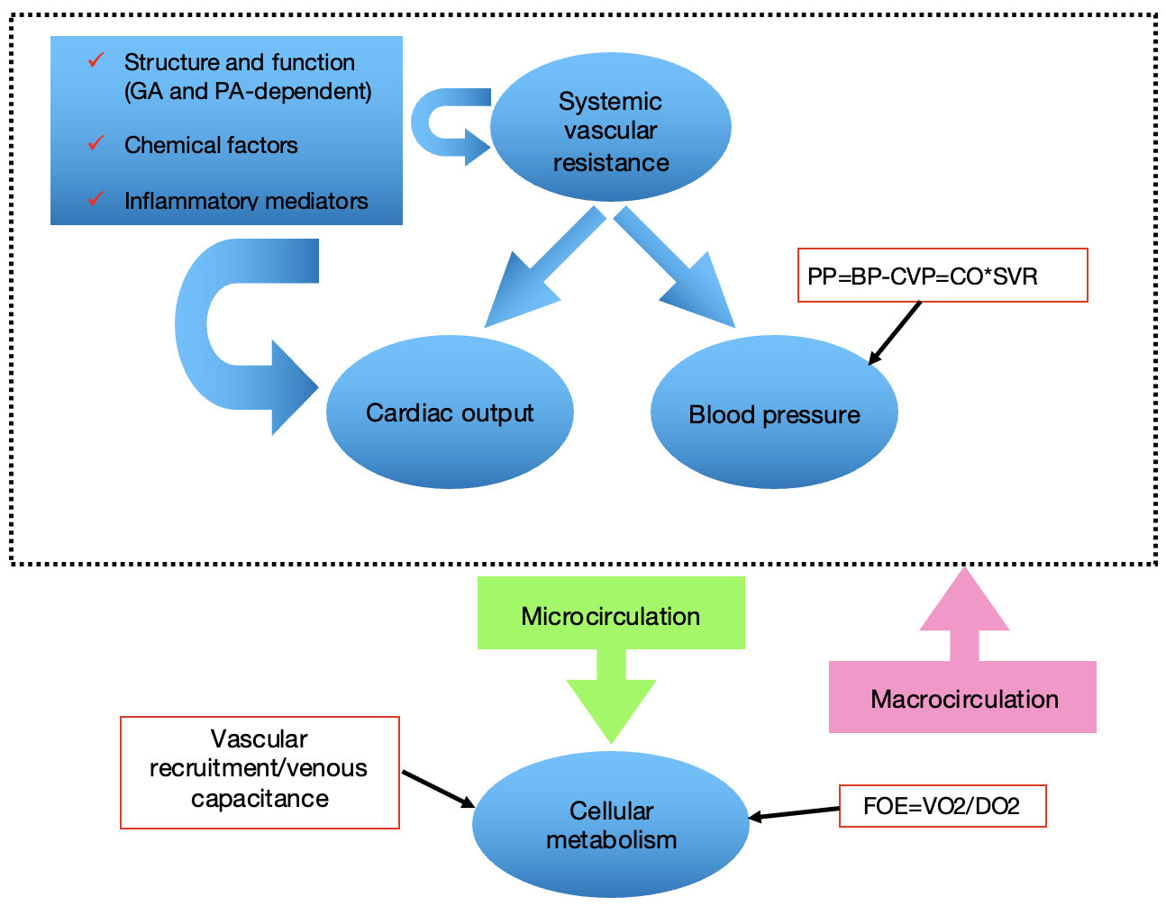

Figure 3. Scheme representing the main determinants of blood flow and metabolism that can be measured at cot-side in infants. GA, gestational age; PA, postnatal age; CO, cardiac output; SVR, systemic vascular resistance; BP, blood pressure; CVP, central venous pressure; FOE, fractional oxygen extraction; VO2, oxygen consumption; DO2, oxygen delivery.

At the level of macro-circulation, the perfusion pressure (PP) is the driving force which moves blood through the vasculature. The PP depends on the CO and the SVR. At the level of the micro-circulation, the resistance of small arteries and arterioles, and changes in venous capacity regulates peripheral blood flow. To meet the metabolic demands, tissue blood flow is normally adjusted according to oxygen consumption. When the blood flow is low in relation to the oxygen needs, then oxygen extraction is increased. The consequence is that oxygen saturation in the venous blood drops. At the cerebral level, if this situation reaches a certain point, we say that the brain is hypoxic and there is a risk that brain cells suffer from hypoxic ischemia.

The regional tissue oxygen saturation (rStO2) is a volume-weighted parameter, representing the oxygenation of arterial, capillary and venous blood, of which the venous contribution is the largest. Therefore, rStO2 can be used as a surrogate measure for venous oxygen saturation (SvO2). From this parameter a continuous estimate of the balance between oxygen delivery (DO2), represented by SpO2 (pulse oximeter), and oxygen consumption can be derived (VO2=SpO2-rStO2). The fractional tissue oxygen extraction (FTOE) can be calculated from the ratio (SpO2-rStO2)/SpO2, that represents VO2/DO2.

- Causes of low rStO2, clinical assessment, and interventions

Low rStO2 (cerebral hypoxia) can be due to suboptimal ventilation, cardio-vascular dysfunction, insufficient oxygen transport capacity, or a combination of these factors. For the clinician to identify the most likely cause of cerebral hypoxia in a given clinical situation, it is necessary that he/she is aware of the potential causes and how to assess them. (Fig.4).

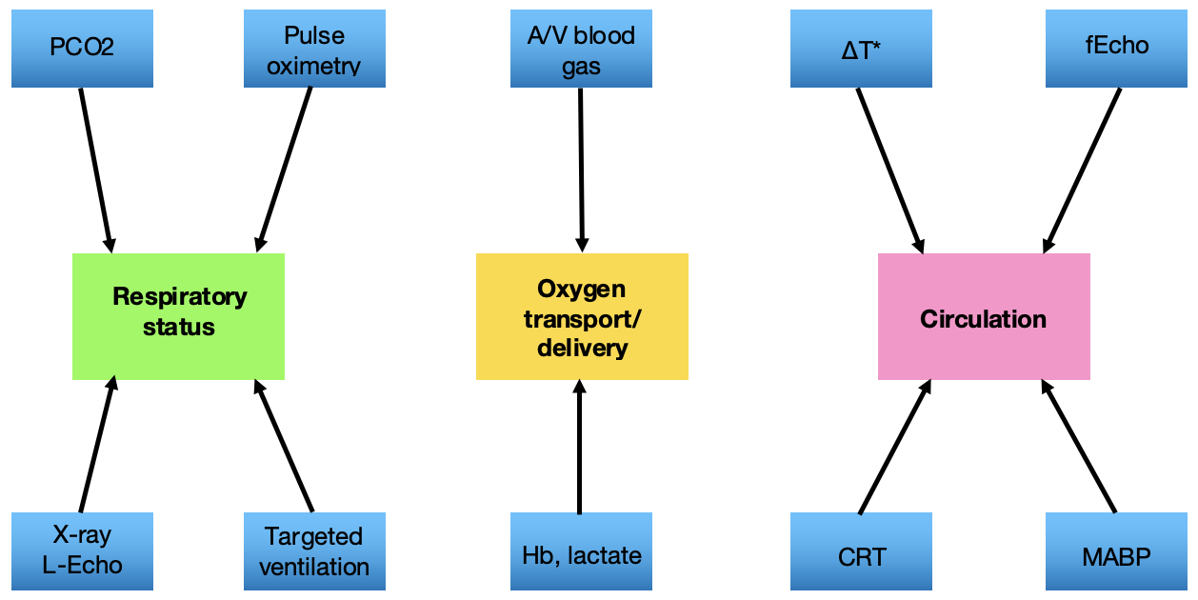
Figure 4. Clinical assessment tools to evaluate potential causes of a low rStO2 in a baby on invasive mechanical ventilation. A/V, arterial/venous; DTº, central-to-peripheral temperature gradient; L-Echo, lung ultrasound; Hb, haemoglobin concentration in blood; CRT, capillary refill time; MABP, mean arterial blood pressure; fECHO, cardiac ultrasound.

A clinical treatment guideline is available for the SafeBoosC-IIIv trial (Fig. 5). This guideline suggests a series of possible interventions when cerebral hypoxia is present and was used in the SafeBoosC-III trial. It is a modified version of the one used in the SafeBoosC-II trial.

The interventions proposed are not listed in a pre-established sequence or prioritized. It was not considered possible to make a flow chart, where defined criteria lead to specific actions, or sequences of actions. The relevance of each of possible interventions depends on an assessment of the complete picture of the infant’s clinical condition. Sometimes the most reasonable ‘action’ may be watchful waiting.

The proposed interventions are all routinely used in clinical care of the unstable, sick neonate, particularly if the baby is on invasive mechanical ventilation.

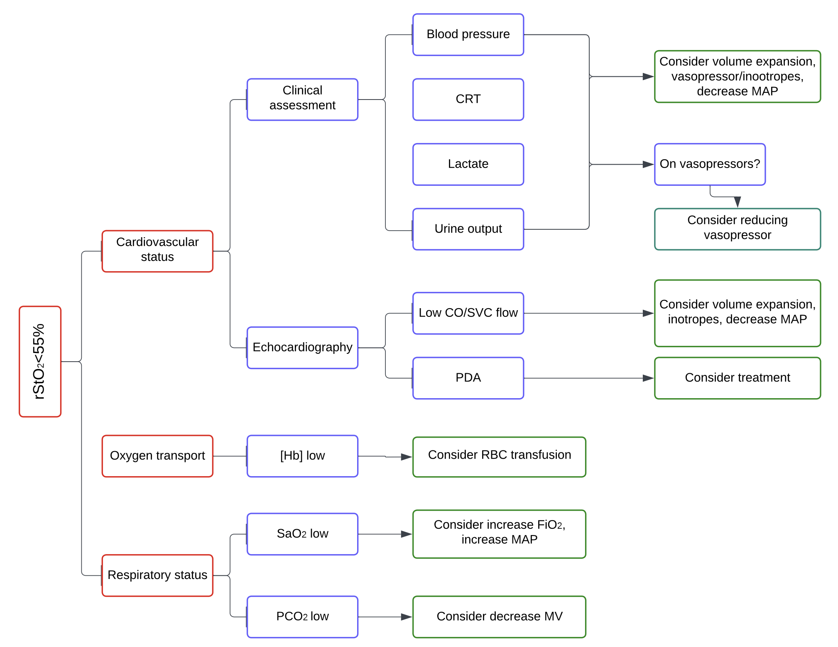
Figure 5. Treatment Guideline for the SafeBoosC-IIIv RCT. In brackets, the level of evidence and recommendation for a given intervention (U.S. Preventive Services Task Force system 2001). Note: The rStO2 value (here 55%), depends on the cerebral oximeter used. CRT, capillary refill time; MAP, mean airway pressure; CO, cardiac output; SVC, superior vena cava flow; PDA, patent ductus arteriosus; Hb, haemoglobin concentration in blood; RBC, red blood cell; SpO2, arterial oxygen saturation by pulse oximetry; MV, minute ventilation.

Respiratory status
The effect of low PCO2 on brain oxygenation. One of the most important determinants of cerebral blood flow and thereby of cerebral oxygenation is partial pressure of carbon dioxide (PCO2). Infants on assisted ventilation, even on volume targeted ventilation, may have inadvertently low PCO2 or a fast decrease in normal range. This has an immediate effect on cerebral blood flow that is reflected in rStO2 (Fig.6).

Intubation and start on mechanical ventilation in healthy lungs (i.e., an invasive procedure with general anaesthesia) may cause huge and fast changes in PCO2. Rapid changes in rStO2 may prompt blood gas evaluation in these infants to adjust ventilation parameters, particularly if end-tidal CO2 or transcutaneous CO2 are not measured.

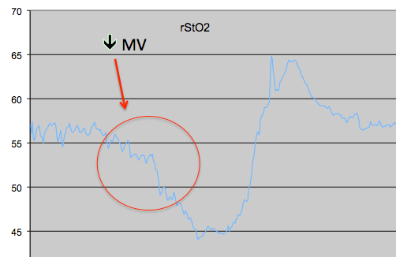
Figure 6. Fast rStO2 decreased trend after start on mechanical ventilation in an infant with RDS. In this example ventilatory parameters (minute volume, tidal volume, or respiratory frequency, depending on the ventilation mode) should be adjusted to hamper the acute effect on CO2 (decrease).

The effect of low SaO2 on brain oxygenation. Normally there is a direct proportionality between changes in SpO2 and in rStO2, so that for example a 5% increase in SpO2 will lead to a 5% increase in StO2. It is crucial, however, not to exceed the upper target threshold for SpO2 (95% in most NICUs) since this will expose the premature infant to the risks of retinopathy of prematurity. If SpO2 is low, then the first step may be to increase supplemental oxygen. Of note, in infants with very sick lungs, insufficient lung recruitment could be the cause. An X-ray may help to judge whether an increase in mean airway pressure could help to increase SpO2. Usually, the positive effect of lung recruitment on SpO2 and rStO2 trends is rather fast. Caution should be taken not to exceed the threshold for SpO2. Caution should also be taken not to over-distend the lungs (Fig. 7), particularly if the infant is on high frequency ventilation, since this may compromise right atrial preload and consequently, reduce pulmonary blood flow and left atrial preload, driving to low left cardiac output (see below). Lung over-distension may also cause a raise in pulmonary vascular resistance, decreased pulmonary blood flow, and protracted hypoxemia.

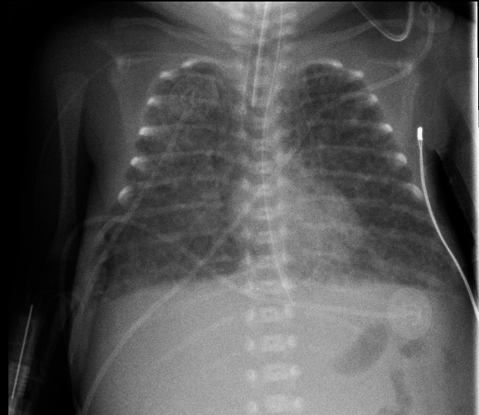
Figure 7. Lung over-distension causing haemodynamic insufficiency due to impaired preload (impaired blood flow back to the heart). Decreasing mean airway pressure is the first step before any other cardiovascular intervention is prescribed. Other pulmonary causes of impaired preload are air leak (pneumothorax) or pericardial/ pleural effusion.

On the other hand, decreased lung volume or compressed lung parenchyma may also be elicited by imaging, either x-ray or lung ultrasound. Events such as air or fluid leak may severely affect lung expansion and compromise right heart preload and pulmonary blood flow. If relevant, space-occupying elements should be relieved.

Impaired lung mechanics may be the result of increased abdominal pressure causing elevation of the diaphragm, such as after surgical closure of abdominal wall defects (Fig. 8). In these cases, actions should be directed at this.

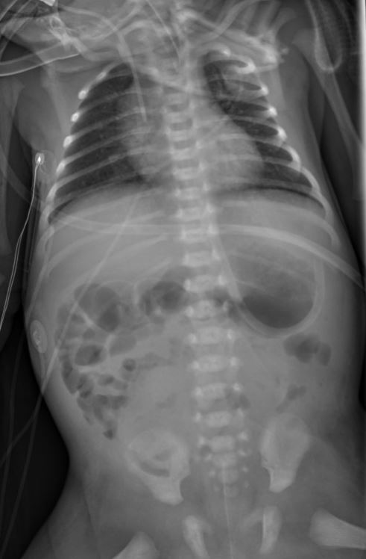
Figure 8. Reduced lung volume and elevated and concave diaphragmatic domes after reintroduction of intestine and liver and closure of the abdominal wall defect in a neonate with congenital omphalocele.

Cardiovascular status: Diagnosis
The diagnosis. Failure to drive oxygenated blood to the organs due to circulatory impairment will usually also lead to decreased cerebral rStO2. Routine clinical assessment of circulation mainly relies on blood pressure (BP) monitoring, either invasive or non-invasive. However, BP alone is a poor surrogate of systemic (and brain) perfusion (Fig. 3). The use of a combination of assessments, in addition to BP, to guide cardiovascular support is recommended. This includes capillary refill time, urine output, or serum blood lactate assessment. Whenever feasible, functional echocardiography is of value, informing about systemic blood flow (superior vena cava flow-SVC flow during transitional period, right ventricular output-RVO, left ventricular output-LVO), preload (filling of the heart), contractility, and abnormal shunts through the foetal channels.

Cardiovascular status: Treatment
The treatment. When a physician suspects impaired circulation to be the cause of low rStO2, he/she should consider either volume expansion, vasopressor-inotrope (dopamine and epinephrine), vasopressor (norepinephrine), inotrope (dobutamine), or inodilator (milrinone) prescription. The effect of these interventions on BP, cardiac output, and cerebral perfusion-oxygenation may be variable. Of note, in the preterm infant during transitional circulation, if CO or SVC flows are low, even if blood pressure is within normal range, it is suggested to start on inotrope treatment (+/-fluid bolus). Impaired myocardial performance is assumed to be the main determinant of circulatory failure in such cases, and therefore, raising muscular tone at the vascular bed (increased afterload) by vasopressors (dopamine, epinephrine, or norepinephrine) can be counterproductive. Low rStO2 may be the sole parameter, indicating that systemic (and cerebral) blood flow is compromised, in an infant who otherwise appear rather well (Fig. 9 and Fig. 10). Following the same line of thought, if an infant is already on vasopressor therapy, particularly if using high doses, the main pharmacodynamic effect may be on the α-adrenergic receptors at the vascular bed, causing further myocardial depression and protracted systemic hypoperfusion. Step-down titration of vasopressors should be considered in this situation.

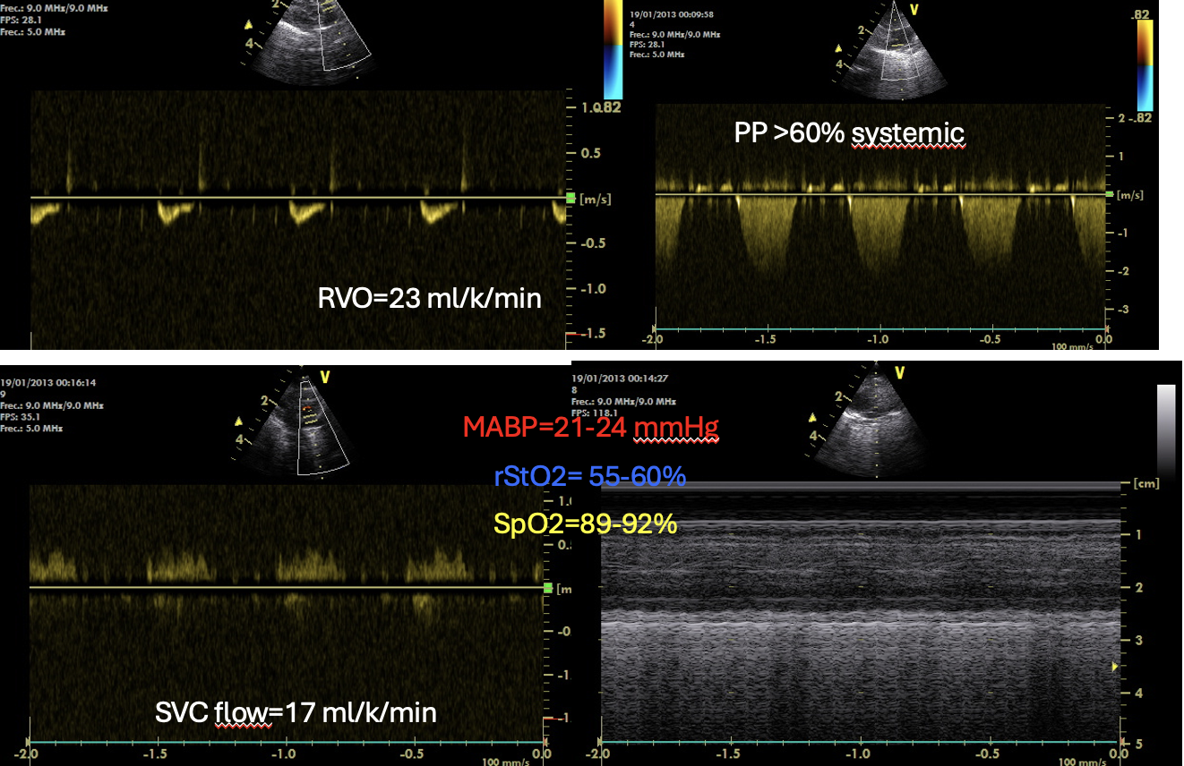
Figure 9. Preterm infant, 23+4 w, <24h after birth. Cerebral rStO2 is maintained between 55% to 60% but SpO2 and MABP are within normal ranges according to NICU policies. Echocardiography revealed very low RVO (< 150 ml/k/min) and SVC flow (<41 ml/k/min) and pulmonary hypertension (PP, pulmonary pressure >60% of systemic pressure). In such case, interventions to improve cardiac output may be used.

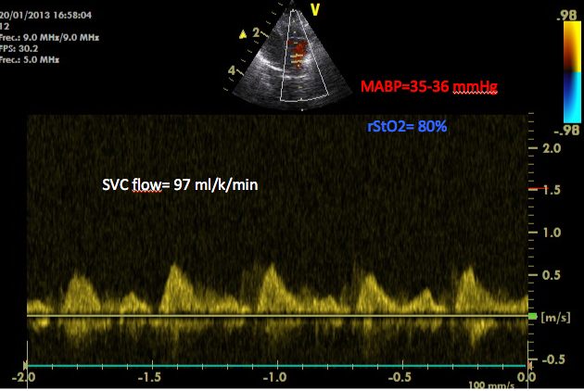
Figure 10. The same infant 3 hours after dobutamine treatment started. No other change in management was implemented.

A haemodynamically significant patent ductus arteriosus (PDA) causing blood flow redistribution towards the lungs, may lead to low systemic and cerebral blood flow and low rStO2. Treatment of PDA may be the most relevant intervention for a low rStO2.
However, in case of surgical PDA closure a low or a decreasing trend in rStO2 may point towards post-ligation cardiac syndrome (PLCS), particularly in infants with documented pre-surgical altered contractility, diastolic dysfunction, and low afterload. The pathophysiology underlaying the process is decreased preload and increased afterload of the left heart after PDA closure, and the upstream impact on the pulmonary vessels.
Of note, if pulmonary pressure with right to left shunts is present, rStO2 will usually be relatively high compared to spO2 – if not, it suggests decreased systemic output, possibly due to poor filling of the left side of the heart.

Oxygen transport
Routine blood sampling may reveal anaemia potentially requiring red blood cell transfusion. Furthermore, during the first hours after birth, hypovolemia may be caused by acute haemorrhage during birth. In contrast, placental-to-foetal transfusion increases rStO2, possibly not only due to increased oxygen carrying capacity but also to improved preload. Infection, coagulopathy, or repeated blood sampling are frequent determinants of early acquired anaemia, often associated with postnatal bleeding, causing insufficient oxygen delivery to the cell, raised serum lactate and acidosis, and low rStO2. Policies regarding transfusion varies among NICUS. In some infants with marginal anaemia and a low rStO2 transfusion may be the most relevant intervention.

- The role of rStO2 in decision making

The use of interventions in situations with alarms for low rStO2 in the SafeBoosC II trial was assessed by post-hoc analysis of the experimental group data, examining the impact on rStO2 and SpO2.

The responses to low rStO2 alarms were grouped in four groups: treatment guidelines (TG) intervention, other action not included in the TG, sensor repositioning, and no-action.

In 55% of alarms no action was taken. In 25% of alarms a TG-intervention was used, while in 14% another clinical management decision was made, and in 5% the sensor was re-positioned (Fig. 11).

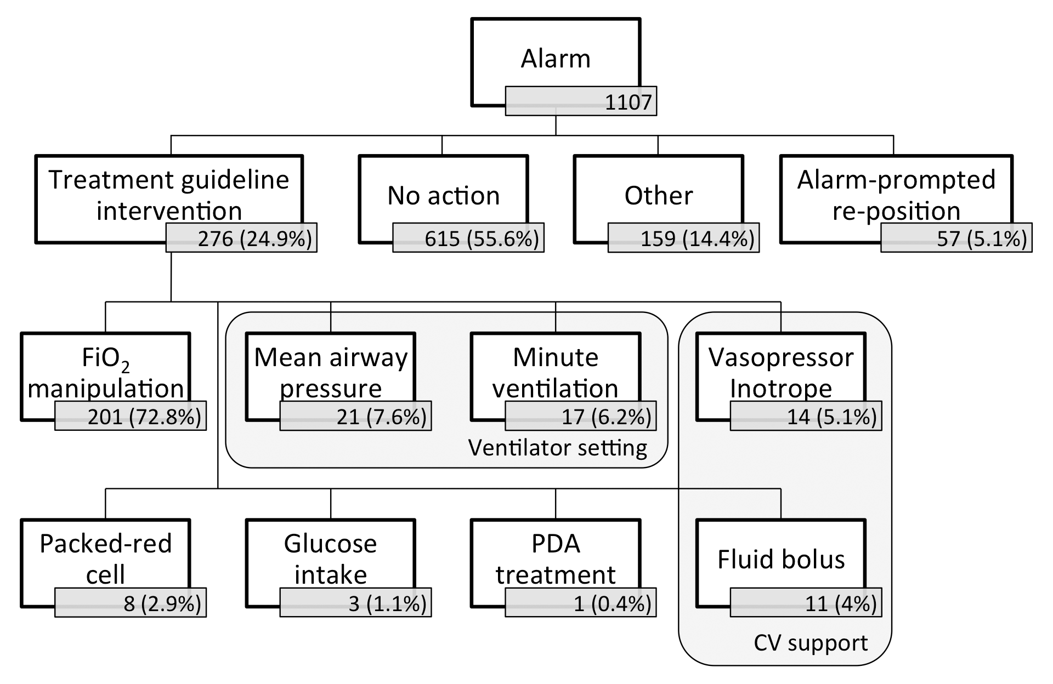
Figure 11. Decisions in response to an alarm in the experimental group in the SafeBoosC-II trial. (Riera et al, Arch Dis Child Fetal Neonatal Ed 2016)

The greatest rise in rStO2 occurred after TG interventions (Fig. 12). But significant rises were also seen after non-TG interventions, sensor repositioning and even after no-action (watchful waiting). We do not know the details which led physicians to choose what to do, so it is unlikely that the four groups were similar. Also, the response of SpO2 differed among the groups. The greatest change in SpO2 occurred after a TG intervention, which makes pathophysiological sense since most intervention were to change in respiratory management. Repositioning the sensor, or not doing anything (watchful waiting) as a response to the alarm, did not cause any changes in SpO2.

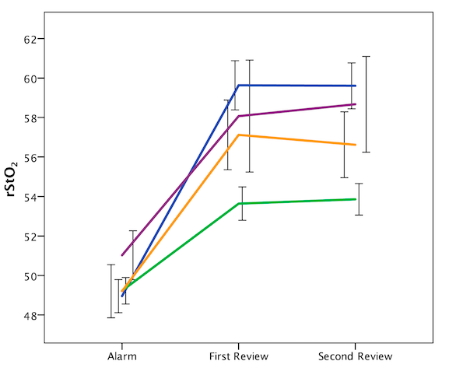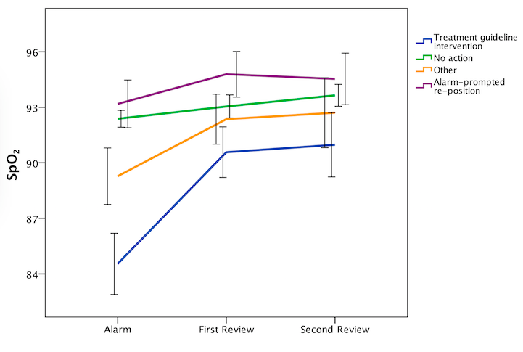
Figure 12. Impact of decision taken in response to alarms in rStO2 and SpO2 (Riera et al, Arch Dis Child Fetal Neonatal Ed 2016)

It is noteworthy that infants in atmospheric air had high SpO2 without having particularly high rStO2 (Table 1). This supports the notion that other factors than SpO2 are important for rStO2 and that FiO2 adjustments should be used sparingly.

Table 1. rStO2 and SpO2 according to level of inspired supplementary oxygen (FiO2) in the SafeBoosC-II trial.

FiO2 value | rStO2 % (SD) [n] | SpO2 % (SD) [n]
21% | 64.9 (15.9) [580] | 94.5 (5.2) [711]§
22-29% | 67.3 (14.8) [376]* | 92.8 (4.6) [447]
≥30% | 63.8 (11.8) [149]* | 92.0 (4.1) [180]
* Differences between 21% and 22-29% FiO2 strata (p=0.001)
§ Differences between 21% and the other two FiO2 strata (p<0.001)

The time needed before rStO2 was back into the target range varied between the groups (Fig. 13). After ‘alarm-prompted re-position’, rStO₂ was back into the normal range within 60 min in 95% of cases. However, after a TG or non-TG intervention, this was only 80-85% of cases. This means that even if the intervention chosen may be appropriate, the mechanism involved in improving brain perfusion-oxygenation, may take time. Furthermore, in some very ill infants, it is likely that cerebral hypoxia was resistant to all interventions.

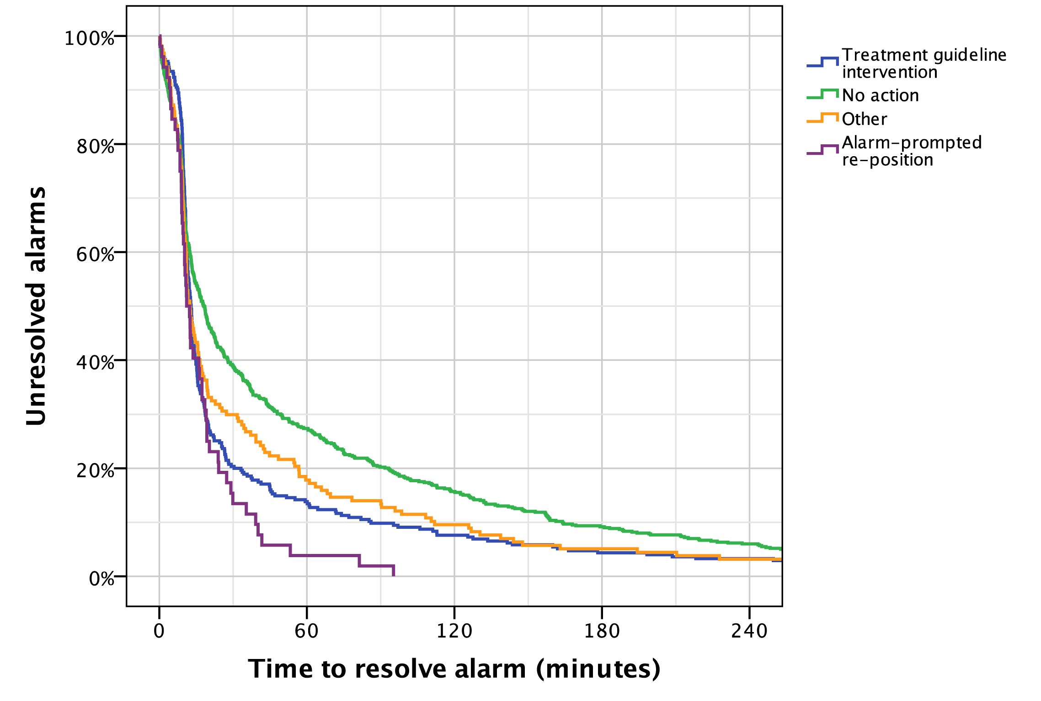
Figure 13. Kaplan-Meier plot diagram representing time needed for the
alarm to be resolved according to type of decision taken (no action vs:
TG intervention p<0.001; sensor reposition p=0.001; other p=0.009)
(Riera et al, Arch Dis Child Fetal Neonatal Ed 2016

- Challenges during the conduct of SafeBoosC-IIIv RCT

The post-hoc analysis of SafeBoosC-II experimental group demonstrated heterogeneity among the participating centres.

a) Reliability of rStO2.
Periodical re-positioning of the NIRS sensor, that was prescribed by the SafeBoosC II protocol, varied between NICUs. Repositions per hour ranged from 0.0 to 0.28. Alarm-prompted repositioning also varied among NICUs, ranging from 0% to 23% of alarms. In the SafeBoosC-IIIv trial it is important to keep in mind, that if the rStO2 differs markedly from what can be expected from the infant’s condition, the precision of the measurement should be questioned, and the sensor should be moved to a different site before management decisions are made.

b) Use of the treatment guideline.
The decisions after rStO2 alarms, also varied among centres. On average, a TG-intervention was used in 25% of alarms but this ranged from 42% to 11% among centres. Some of this difference may be due to differences in the concern about cerebral hypoxia, and some may be due to the fact the clinical management also depend on other monitoring devices and other clinical information. Only the interventions triggered by NIRS alarms were analysed. It is clear, however, that the benefit of extra monitoring, as tested in the SafeBoosC-IIIv trial, depends on effective use of abnormal values for modifying clinical management. This means prompt and adequate reactions to monitor’s information.

During the conduct of the SafeBoosC-III trial, 29% of the clinical records of the participants in the experimental group contained a clinical note of a change in management due to cerebral hypoxia. The use of cardiovascular support was higher in the experimental (36%) compared to the control (30%) group, whereas the use of mechanical ventilation and PDA treatment was similar to the control group.

c) How to set and use alarms.
In the SafeBoosc-II trial, different cerebral oximeters were used, but due to the blinded nature of the trial, oximeters were hidden in a box and rStO2 with a trend was displayed on a computer screen. The computer program also provided an audible alarm after an accumulated 0.2 %hours (12 %minutes) rStO2 outside the target range – faster when rStO2 was far out (one minute or rStO2 was 12% below the target range, and slower when rStO2 was just outside the range (12 minutes if rStO2 was 1% below the target range (Fig. 14).

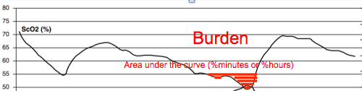
Figure 14. Representation of the accumulated rStO2 values until alert system in SafeBoosC-II RCT experimental group.

In the SafeBoosC-IIIv trial oximeters will be used as they are, usually with simple alarms that go off without delay. This means that decisions will have to be made of where to set the hypoxic alarm limit and how fast to react.

Marginal hypoxia of the brain takes some time to cause injury. In total anoxia, severe brain injury occurs within minutes, but in a situation with marginal hypoxia, the first cellular reactions are to decrease metabolic expenses. The relative resistance of neonates to hypoxia is due to the effectiveness of these processes in the normal neonatal brain. But it is likely that neonatal brains influenced by inflammation, growth restriction or other pathology may be more vulnerable, and also likely that marginal hypoxia may set off slow, detrimental processes other than mere cell death.

The realistic aim of the SafeBoosC-IIIv trial is to reduce the risk of unrecognised deep, critical cerebral hypoxia and to reduce the overall burden of graded cerebral hypoxia and the clinically relevant consequences of that, during the use of invasive mechanical ventilation within the first 28 days from birth.

Quiz

Learning objectives

By the end of this module participants will be able to:
- Understand the pathophysiology of transitional circulation and the circulatory side-effects of mechanical ventilation
- Understand causes of disturbances of brain perfusion, which biomarkers/assessments that can be used to evaluate the infant’s clinical condition, and suggested interventions to restore rStO2 within normal range
- Understand the role of rStO2 in decision making
- Understand the challenges that we can face during the conduct of SafeBoosC-IIIv

An example of a quiz case.
Please note that several answers may be appropriate, but we ask you to choose the most appropriate answer. This is to mimic the clinical situation where the cerebral oxygenation is low, and several interventions could be relevant. The challenge of the clinician is to choose the single intervention that is most reasonable given all the available information. In all but critical situations, it is recommended to do one intervention at a time and wait for the effect on cerebral oxygenation before prescribing another intervention. In critical situations, it is important to know what not to do.

Do not give up if your choice of answer is turned down. Read the explanation and try again. We hope that the explanations we provide will help you succeed in the end.

Test case
A boy was born after spontaneous contractions since the day before yesterday. Initially, the contractions were stopped with atosiban. Had one dose of corticosteroids. Contractions reappeared again and the boy was born, vaginal delivery with intact membranes, at 28+3 weeks. BW 890 g. No asphyxia. Intubated in the delivery room and given surfactant. Once in the NICU umbilical catheters were placed. Now, at 3 hours of age, he is on IPPV, antibiotics and morphine. He appears vigorous with good skin colour. Temperature is 36.6.

IPPV: pressure 25 / 6, Ti = 0.3, Te = 0.6, FiO2 55%
Hb 7.1 = 11.5 g/dl
SpO2 = 87%, pO2 = 60 mmHg
MABP 24 mmHg
The blood gas shows pCO2 = 37 mmHg, pH = 7.38

The boy looks fine, CRT 2-3 s, but the cerebral oxygenation is 6% below the hypoxic threshold of your cerebral oximeter. What could be done?:
- Red blood cell transfusion
- Increase FiO2
- Give vasopressor to increase blood pressure
- Reduce inspiratory pressure or target tidal volume
- Reduce PEEP

Answers
- Wrong. It is correct that red blood cell transfusion will lead to increased haemoglobin levels and proportionally increased oxygen carrying capacity. An increase in haemoglobin from 7 to 8 mmol/l will therefore improve oxygen transport by 15%. however, the viscosity of the blood will also increase and may subtract from the effect - and there is a better alternative.
- Wrong. Increasing FiO2 will increase SpO2, not rStO2 (cerebral tissue oxygenation). Even increasing FiO2 to get SpO2 at the maximal safe level of 95%, will increase oxygen transport by 8%. Furthermore, the risk of hyperoxic complications such as retinopathy of prematurity should be considered, and cerebral hypoxia should never lead to the use of oxygen in excess of what is needed to keep arterial oxygenation within normal range - and there is a better alternative.
- Wrong. It is correct that vasopressor administration will increase blood pressure, and since autoregulation is unlikely to be perfect in this infant, it is likely that this will lead to an increased cerebral blood flow and oxygenation. But the reactivity usually is in the range of 1-3% change in cerebral blood flow per mmHg change in blood pressure. This corresponds to a 0.5-1.5% change in oxygenation. This means that increasing blood pressure to 35 mmHg will lead to an increase in cerebral oxygenation by 6 to 18 %. And there is a better alternative.
- Correct. Decreasing ventilation will increase pCO2, which is a strong cerebral vasodilator. Since the pCO2 of this infant, at the time of the blood gas, is likely to be lower than before, a full effect of 4% CBF per mmHg pCO2 can be expected. pCO2 could be allowed to increase to 50 mmHg and this would be expected to increase cerebral oxygenation by 25%. Furthermore, this is likely to reduce the mechanical stress to the lungs.
- Wrong. It is true that reducing peep, may reduce pressure in the chest and improve the blood flow back to the heart, increase preload, and hence improve cardiac output. However, in this infant with a high oxygen requirement, the lungs are still likely to be non-compliant, and a reduction in PEEP is likely to increase oxygen needs. If still in doubt, a chest X-ray should be done to document overfilling of the lungs.

Quiz cases

- (Objective 1).
Following air entrance into the lungs after birth, the following physiological change in circulation occurs (tick the most appropriate answer):
- Sudden rise in pO2, causes pulmonary vascular bed vasodilation and a rise in systemic vascular resistance
- Sudden rise in pO2 causes a drop in pulmonary vascular bed resistance and in a drop in systemic vascular resistance.
- The expel of lung fluids during birth, creates room for pulmonary vascular bed filling.
- The ductus arteriosus remains open to guarantee blood flow to the organs.

Answers
- Correct. Start of breathing causes the lungs to fill with air (oxygen), which increases pO2. Oxygen is a vasodilator in the vascular bed in the lungs, but in other arteries, increased pO2 causes vasoconstriction, and therefore increased systemic vascular resistance.
- Wrong. While it is true that air entrance into the lungs causes pO2 to rise, and that pulmonary arteries dilate in response to the increase in pO2, it also has a significant effect in the systemic circulation by causing vasoconstriction and thereby, increased systemic vascular resistance. In foetal life, SpO2 is only about 70% and during birth it may be even lower. This hypoxia maintains a degree of dilation of the systemic vascular bed.
- Wrong. While lung fluid is expressed through the trachea during delivery, and more fluid is absorbed from lung tissue when pO2 increase, this room is taken up by air.
- Wrong. While it is true that the arterial duct typically remains open for some time after birth, and in preterm infants even for many days after birth, an ‘adult’-type circulation is normally established in the first minutes after birth. The resistance of the pulmonary vascular bed decreases sufficiently, for almost all of the output of the right ventricle to pass to the lungs.

- (Objective 2 & 3)
Baby-Gil is a 35+4 girl affected by congenital chylothorax. Immediately after birth, pleural catheters were placed in both hemi thoraxes through which fluid drains continuously. She also received 1 dose of surfactant after initial fluid removal due to persistent hypoxemia at 3 hours from birth. Now she is stable with FiO2 between 30%% and 35%, but over the last 30 minutes, rStO2 is progressively decreasing, while still just above the hypoxic threshold. SpO2 has been between 87% and 91%. What should you do? (tick the most appropriate action):
- Wait and see because rStO2 is in normal range
- Check by lung ultrasound or X-ray if fluid is accumulating in pleural space and needs more effective removal
- Check blood pressure, if normal, wait and see
- Take blood gas to see if lactate is rising
- Check the arterial blood gases to see if the infant is being hyperventilated

Answers
- Wrong. Even if rStO2 (still) and other monitoring parameters are in the normal range, a progressive decrease in rStO2 should raise the suspicion of potential problems in this sick infant.
- Correct. This would be a good first consideration. Progressive fluid trapping in the pleural space may cause relative hypovolemia, compression of the lung and mediastinum causing decreased preload. It may take some time until other clinical signs of low cardiac output or hypoventilation appear. An x-ray or lung ultrasound may be indicated if doubts persist.
- Wrong. It is correct that blood pressure should be measured, but even if it is within normal range, it does not exclude a decreasing cardiac output as the cause of the steadily decreasing rStO2.
- Wrong. While it is correct that an elevated blood lactate is an indicator of organ hypoxia, it should not be the first choice in this particular infant, partly since lactate does take time to increase, and partly since we know that this infant has a pleural effusion.
- Wrong. Pleural effusion often leads to increased pCO2 due to lung compression, in particular in babies who are ventilated without volume guarantee. When the fluid is relieved by drainage, this is usually rapidly reversed and the drop in pCO2 is followed by an immediate and rapid drop in rStO2. In the case of Baby-Gil, the drop in rStO2 came slower.

- (Objective 2 & 3)
Baby-Fufu is a twin brother born at 29+3 weeks and the recipient of foetal-to-foetal transfusion. He was intubated after birth due to high oxygen demand and hypercapnia. He had surfactant and arterial blood pressure dropped to 26 mmHg. Now at 4 hours of age, he is stabilised on vasopressor treatment (dopamine 7.5 μg/kg/min), invasive mean blood pressure is around 31 mmHg, SpO2 91% and rStO2 a few % below the hypoxic threshold of your oximeter. Blood gas analysis show PCO2 51 mmHg (6.8 kPa), Hb 15.3 g/dL, and lactate 2.7mmol/L. What would your judgement be? (tick the most appropriate answer):
- Baby-Fufu is just fine
- Cerebral oxygenation is indicating that something could be improved. Echocardiography could be informative.
- Baby-Fufu probably needs volume expansion to improve blood flow.
- Wait a couple of hours, in order to evaluate urine output and hereafter re-assess treatment.

Answers
- Wrong. It is possible, that baby-Fufu’s clinical condition is fine, but if the rStO2 values are accurate, one should be worried about the cerebral perfusion, due to the circumstances and history of the infant.
- Correct. As a twin-to-twin transfusion syndrome recipient, baby-Fufu’s heart has been handling an excessive volume in foetal life, and therefore potentially is hypertrophic. Echocardiography (Fig.15) could confirm this and indicate if dopamine impairs the filling of the heart in diastole and thus, paradoxically, cause a low CO. Step-down of dopamine should be considered.

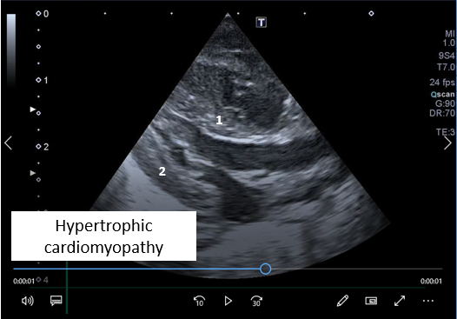
Figure 15. The figure illustrates a long parasternal view showing hypertrophic cardiomyopathy, the interventricular septum (1) and the left ventricular posterior wall (2) is thick.

- Wrong. It is normally reasonable to consider volume expansion to (briefly) increase preload. However, based on the infant’s history as the blood recipient, it may be assumed that this infant is either normo- or hypervolemic.
- Wrong. The pathophysiological background of Baby-Fufu, combined with marginal cerebral hypoxia should call for further evaluation. Two hours of cerebral hypoxia due to over-treatment with vasopressor would be unacceptable.

- (Objective 2 & 3)
Baby-Yeah is 30+2 week, born by c-section after acute placental detachment. No antenatal steroids. She was intubated shortly after birth and received early surfactant due to severe hypoxia. At 5 hours from birth, she is on volume-control, pressure-regulated ventilation with 7 mL/kg tidal volume, mean airway pressure around 17 cm H2O and FiO2 21%. Invasive mean blood pressure is 29 to 31 mmHg, she passes urine, and she moves when touched, although remains calmed if undisturbed, so that do not need sedation. Cerebral oxygenation has been slowly, but consistently decreasing during the last 30 min, and has passed the hypoxic threshold of your oximeter. What would you do? (tick the most appropriate answer):
- Reposition the sensor to see if the oximeter reading is reliable.
- Wait and see.
- Check PCO2 levels and adjust ventilator parameters accordingly.
- Check the blood haemoglobin
- Start vasopressor.

Answers
- Wrong. There is a gradual decrease in rStO2 over some time. Baby-Yeah is only 5 hours old, so there is no reason to re-position the sensor yet. Unless there is another reason to doubt the quality of the reading, the baby should not be disturbed by this.
- Wrong. Although it appears that Baby-Yeah has recovered quickly and is doing well in most respects, a consistent downward slope of rStO2 for 30 minutes should not be ignored.
- Correct. Baby-Yeah’s respiratory status has changed due to surfactant therapy and the programmed ventilator settings (tidal volume or the back-up frequency) are too high and she may now be over-ventilated due to rapidly improved lung function. A blood sample to check for pCO2 should be taken. A decreasing pCO2 may result in iatrogenic cerebral ischemia and brain injury. In the absence of continuous pCO2 trend monitoring, changes in rStO2 in ventilated infants are particularly valuable.
- Wrong. It is true that placental detachment may cause foetal blood loss, and that it may take hours for blood haemoglobin to equalise. But a significant foetal blood loss would be expected to cause low CO due to hypovolaemia immediately after birth and does not well explain the steady decrease of rStO2 several hours after birth.
- Wrong. It is true that the blood pressure is marginally low. The diuresis, however, suggests that perfusion pressure to the kidney is adequate. This suggests a specific brain cause, i.e. hypocapnia.

- (Objective 2 & 3)
Baby-Rigs was born at 40 weeks + 5 days by c-section due to congenital gastroschisis with all the intestine and part of the liver outside the abdominal cavity at birth. A silo was placed soon after birth and progressively squeezed day-by-day. Abdominal pressure has been continuously monitored by bladder catheter. At day 7, surgeons approximate and close the abdominal wall apparently without technical problems. After the procedure, the baby is very sensitive to handling (becomes hypoxic), the abdomen is tense although depressible, abdominal pressure is 4-5 points higher, and ventilator peak inspiratory pressure has raised to deliver the tidal volume set. Blood pressure is within normal range. The infant’s appearance is pale and rStO2 is consistently lower than pre-surgical closure. What should you do? (tick the most appropriate answer):
- Buah! this silly instrument (the cerebral oximeter) is not accurate. You should not do anything.
- Decrease minute ventilation because the wall defect is over so that lung volume and mechanics would have improved and lung over-distension may compromise pulmonary blood flow and cause hypoxemia, among others.
- Ask for an echocardiography to rule out pulmonary hypertension.
- Order an x-ray to judge the lung gas volume and diaphragm position.
- Get a blood sample to check blood haemoglobin because the infant is pale

Answers
- Wrong. It is true that cerebral oximetry has limited accuracy. If in doubt of the oximeter’s reliability, the sensor should be checked and possibly moved. Disregarding rStO2 will not give the SafeBoosC-IIIv trial a chance to demonstrate the value of cerebral oximetry.
- Wrong. Baby-Rigs’s oxygenation is dependent on adequate lung volume and the baby’s respiratory drive. Closure of the abdominal wall in a gastroschisis does not improve lung mechanics nor lung volume; in addition, during the immediate postoperative period the baby is still sedated with no spontaneous respiratory effort, therefore lung overdistension or hyperventilation is not expected. It would be safe to assess lung volume by x-ray at first.
- Wrong. If pulmonary hypertension has not been documented earlier this pathophysiology is not likely behind the observed effect.
- Correct. It is reasonable to check lung volume by x-ray. Lung compression due to raised intra-abdominal pressure may be the consequence of abdominal wall closure in this context. The higher post-procedure abdominal pressure and ventilator peak inspiratory pressure support this notion. The consistently low rStO2 and the infant’s pale (vasoconstriction) aspect point towards low pulmonary and systemic blood flow as a result of severe lung compression.
- Wrong. While a pale skin and low rStO2 combined with a normal SpO2 could be explained by low blood haemoglobin, is less likely in this case. The problem came rather abruptly, and there are no reasons to suspect an acute blood loss.

- (Objective 2 & 3)
Baby-Lou is a 39+3-week new-born with the antenatal diagnosis of Congenital Diaphragmatic Hernia (CDH). Since 48 hours from birth undergoes Extracorporeal membrane oxygenation (ECMO) therapy. Currently (ECMO day+5), the defect is already surgically corrected (ECMO day+1) and the echocardiogram shows improved pulmonary hypertension. The baby’s SpO2 is maintained around 95% with HFOV (MAP 11cm H2O; TV 1.5 mL/kg; 12 Hz; FiO2 30%), and 240 mL/min and FiO2 40% as oxygenator settings. The baby has regular urine output (2.5 ml/Kg/h) and blood pressure 75(SBP), 45 (DBP) and 50 (MABP). During the last 60 min, cerebral rStO2 shows decreasing trends. What should you do? (Tick the most appropriate answer).
- Hypovolemia is the most likely cause and volume trial should be given.
- Increase membrane oxygenator settings (flow and FiO2) as the brain becomes progressively more hypoxic
- Increase ventilator settings (MAP, FiO2) for the same reason.
- The patient’s condition is improving, therefore the pCO2 is probably decreasing.
- There is a clot in the system, and it should be revised.

Answers
- Wrong. There is no clinical data supporting hypovolemic status according to other circulatory parameters (urine output or blood pressure).
- Wrong. SpO2 is within normal range, so no reason to increase FiO2.
- Wrong. As above.
- Correct. This stable patient shows clear signs of improvement and potential changes (decreased) on pCO2 might be the consequence. Blood gas helps to adjust ventilator and oxygenator settings in the face of advancing in ECMO weaning.
- Wrong. There has not been a clinical deterioration of the patient’s status to think on ECMO system failure.

- (Objective 2 & 3)
Baby-Fio was born at 33+2 weeks’ gestation and currently is at her 36+3 weeks’ postmenstrual age. She is still admitted in intermediate care ward (pre-discharge) due to feeding problems and obstructive apneas. After the last meal, she becomes blue with severe work of breathing and vomitting. An x-ray depicts severe stomach distension and collapsed, non-homogeneous lung infiltrates (Fig.16A). The status of the baby deteriorates and HFOV/ FiO2 80% is started due to severe respiratory insufficiency. After initial stabilization monitoring trends show: consistent SpO2 arround 93% with FiO2 50%, progressive downsloped rStO2 trends though still above the hypoxic threshold, and normal blood pressure. X-ray is ordered (Fig.16B). What should you do? (tick the most appropriate answer).
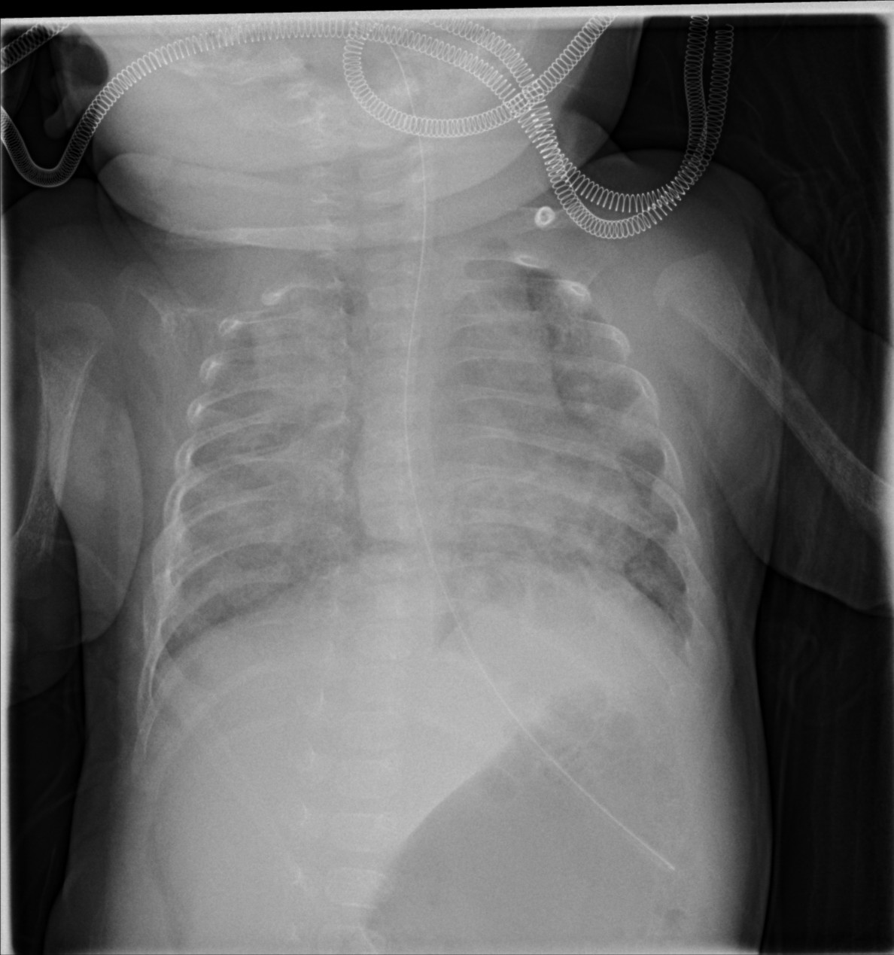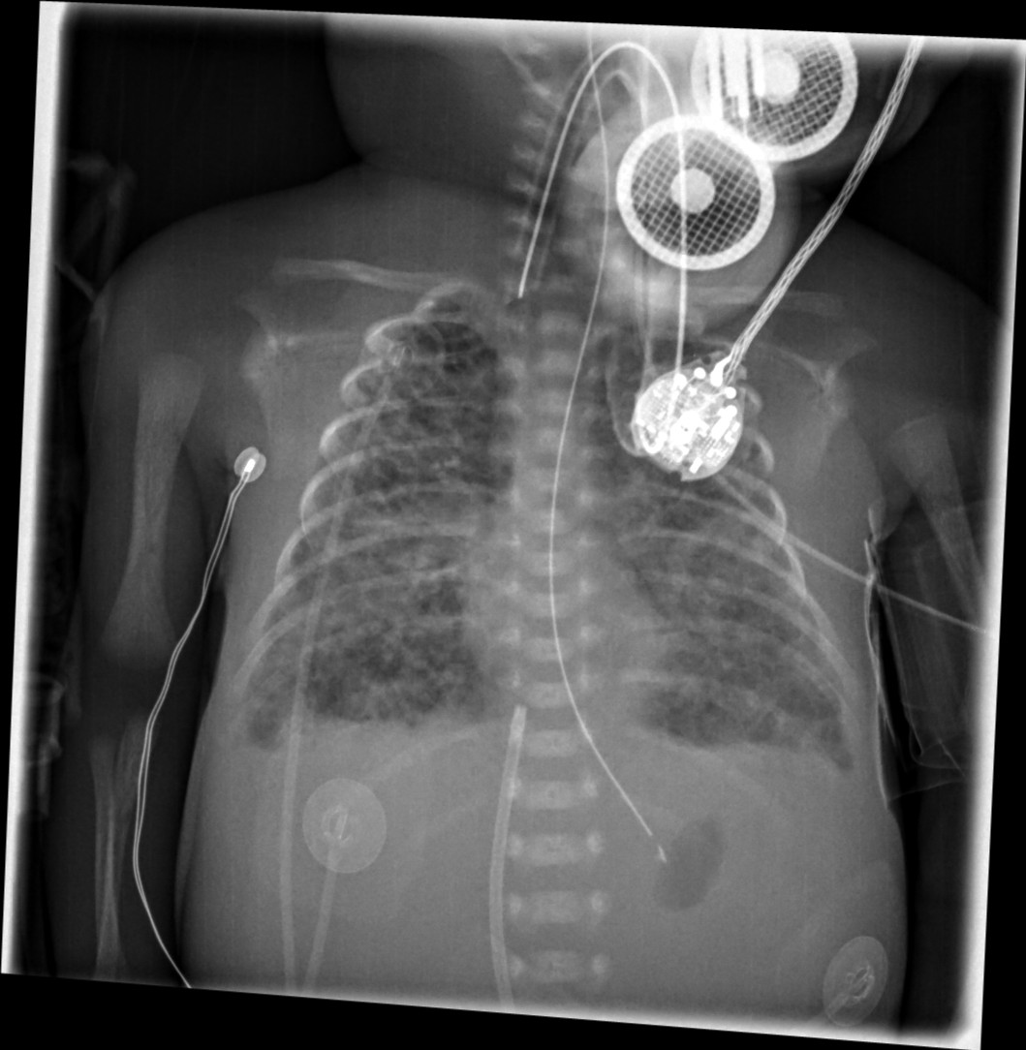
Figure 16. X-ray showing: A) left panel, over-distention of stomach and diffuse, non-homogeneous lung infiltrates with reduced lung volume; B) endo-tracheal tube, lung bilateral small diffuse infiltrates and interstitial emphysema, narrowed mediastinum-heart shape, flattened diaphragms, empty stomach with tube, and catheter in the inferior vena cava.

  - The x-ray is fine, the FiO2 requirement is reduce, no further changes should be accomplished
  - This is not the time to order a blood gas because all physiological parameters are within the normal range.
  - The rStO2 sensor should be repositioned
  - Decrease mean airway pressure because there is lung overdistension
  - Increase FiO2

Answers
- Wrong. X-ray in Fig16A shows 7^{1/2} intercostal spaces and the control x-ray (Fig 16B) depicts 9^{1/2}. Mediastinum is squeezed and diaphragms are flattened.
- Wrong. Yes, SpO2 is stable with lower supplementary oxygen requirement and blood pressure is within normal range due to vasoconstriction (compensated shock). Observed rStO2 trends worry, however.
- Wrong. The baby is too sick and heavily supported so that this should be the last action after checking everything is fine.
- Correct. The new x-ray (Fig.16B) shows overdistension of lungs and compressed mediastinum. Although blood pressurre is within nomal range, systemic blood flow may be compromised. If echocardiography is available, systemic blood flow should be cheked. Alternatively, we can start decreasing mean airway pressure carefuly, above the airway closing pressure, and see the effect it causes on SpO2 and rStO2.
- Wrong. FiO2 should not be ajusted as first option as SpO2 is stable even after FiO2 is decreased. As TC CO2 is not monitored, the decreasing trends in rStO2 could point towards hyperventilation state, further contributing to the cerebral low blood flow supply. Blood gas could be ordered also.

- (Objective 2 & 3)
Baby-Star was born at 34+2 weeks’ gestation due to maternal chorioamnionitis. Shortly after birth, clinical signs of respiratory failure with severe hypoxemia were present with need of supplementary oxygen up to 90%, regardless progressive increase in MAP delivered by nasal CPAP. The baby was intubated, and surfactant was administered without clear improvement. Transfer to our hospital is reclaimed. On admission an x-ray is ordered (Fig.17) Pre-ductal SpO2 is 94% and post ductal SpO2 is 84% so that iNO is started. Pre-ductal SpO2 raises to 98% and the pre-post ductal gradient (3%) and FiO2 requirements (50%) are lower but rStO2 show decreasing trends.
What should you do? (tick the most appropriate answer).

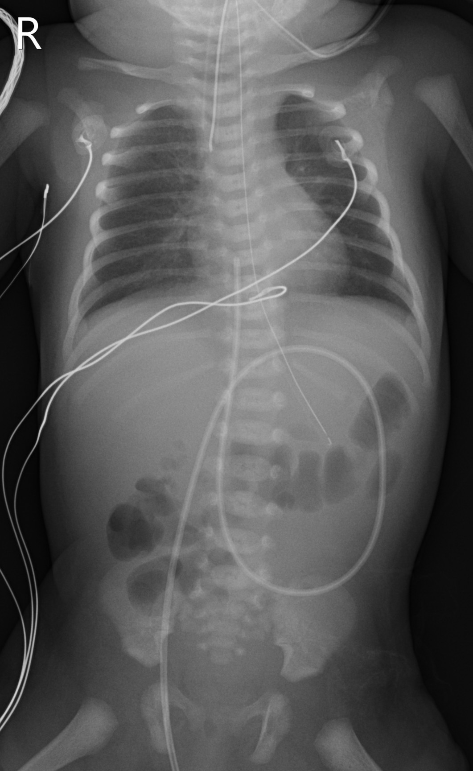
Figure 17. X-ray showing open-airy lungs with non-specific parenchymal changes. Adequate lung volume.

- Return to the initial FiO2 levels (90%)
- Ignore rStO2 as the baby is doing better
- Order an echocardiography
- Increase MAP
- Prescribe normal saline infusion

Answers
- Wrong. No reason to do so as PPH apparently is improving
- Wrong. Not a good idea. A monitor is not an ornament.
- Correct. On admission the baby was too sick, the lungs were open, the cardiologist was not in house, and the diagnosis of PPH was rather clear. iNO was the best option at this stage. BUT echocardiography is needed because the pathophysiology of PPH is diverse. In this case, the status of the myocardial performance has not been evaluated yet. We are facing most probable situation of left ventricular dysfunction and iNO favours pulmonary blood flow, increased left heart blood flow return, and reduced right to left shunt through the ductus, that is supporting the systemic blood flow and, therefore the cerebral perfusion.
- Wrong. Not a good idea. Lungs were already open and due to potential persistent pulmonary hypertension and left ventricular dysfunction, increasing MAP could even worsen the condition.
- Wrong. Not a good idea. In left heart failure fluid overload can worsen the condition leading to pulmonary oedema.

- (Objectives 4)
In relation to the SafeBoosC-IIIv treatment guideline, which of the following statements is true? (tick the most appropriate answer):
- The treatment guideline consists of a prioritised list of interventions to optimize circulation, ventilation and oxygen transport.
- One of the interventions must be done when cerebral hypoxia appears, i.e. the rStO2 drops below the hypoxic threshold of your oximeter
- The proposed interventions are all parts of routine clinical care of the sick neonate requiring highly specialized neonatal care.
- The interventions in the treatment guideline are based on a high grade of evidence

Answers
- Wrong. It is correct that it consists of a pre-established list of interventions that can be used to optimize circulation, ventilation and oxygen transport. However, it is a non-prioritized list. The responsible clinician should evaluate all other clinically relevant information, before choosing the most appropriate action.
- Wrong. The treatment guideline suggests the use of these interventions. Frequently, it may be safest to check the sensor, and possibly to move it before changing management, and in some situations the best option may be to wait and see – as for other routinely monitored variables such as SpO2 or blood pressure.
- Correct. The proposed interventions are all routinely used in clinical care of sick infants during their stay in NICU, particularly if ventilation or circulation is supported.
- Wrong. Although it is true that many of the proposed interventions are based on good knowledge of the pathophysiology of transitional circulation, their effects on cerebral oxygenation have not always been demonstrated in similar clinically scenarios.

