NIRS module – SafeBoosC-IIIv

Welcome to the learning material on near-infrared spectroscopy (NIRS) monitoring. On the following pages you will be introduced to the most important aspects of NIRS monitoring in newborn babies. Reading this will help you get through the quiz faster. However, all answers to quiz questions cannot be found directly in this learning material – in some cases, you will also have to use your own clinical skills to solve them.

Within this learning material, we will present to you a case, like those that you will meet during the quiz.

The learning material is rather short and dense. This is done to minimise reading time. Therefore, please read the material carefully.

Definitions
A tissue oximeter measures oxygen in tissue with the use of near-infrared spectroscopy (NIRS). It is measured in percentage (%) – from 0 to 100% - and is labelled rStO₂. rStO₂ represents the oxygen saturation of haemoglobin in the tissue.

Tissue oximeter differs from pulse oximeter
rStO₂ differs from arterial saturation measured by a pulse oximeter (SpO₂). A pulse oximeter uses the pulsation of the arteries to identify and isolate the signal from the arterial blood. It reflects mainly the arterial oxygen content. The tissue oximeter is not dependent on pulsation. And therefore, it is the blood in all blood vessels, arteries, capillaries, and veins that is measured. Since most of the blood is in veins, rStO₂ is called ‘venous-weighted’ and reflects mainly the venous oxygen content. Typical values for the tissue oximeter are 60-80% rather than 90-95% for the pulse oximeter. In contrast with the narrow range of normal values in arterial oxygen saturation, the range is thus much broader for the venous oxygen saturation. rStO₂ is the end-result of the balance between the oxygen delivery (amount of oxygen taken to the brain and dependent on the arterial oxygen content and the cerebral blood flow) and the cerebral oxygen consumption (dependent on cerebral metabolism). So, when the arterial oxygen content (reflected by arterial oxygen saturation) and oxygen consumption remain stable, changes in rStO₂ will reflect changes in cerebral blood flow. This means that a drop in blood pressure or drop in cardiac output, could cause a decrease in rStO₂ – and an increase in blood pressure or cardiac output could cause an increase in rStO₂. This is different from pulse oximetry, which primarily relies on the lungs ability to oxygenate blood and is independent of tissue perfusion. However, the pulse oximeter may not be able to detect a signal during circulatory failure, since this depends on pulsation. It may even show falsely low SpO₂ values during such events.

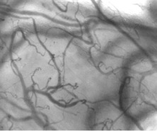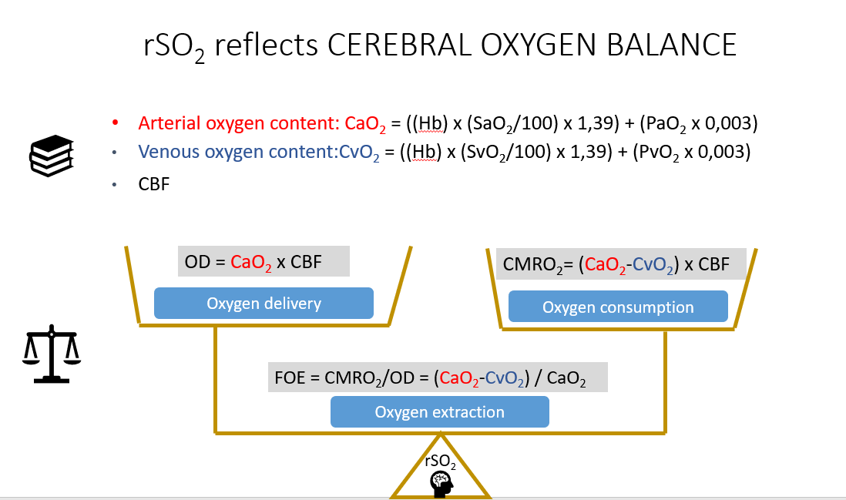
Tissue with arteries, capillaries and veins. rSO₂ refers to rStO₂: tissue oxygen saturation. SaO₂ refers to SpO₂: arteriel oxygen saturation. SvO₂: venous oxygen saturation. FOE: fractional oxygen extraction. OD: oxygen delivery. CMRO₂: cerebral metabolic rate of oxygen. CBF: cerebral blood flow. CaO₂: arterial oxygen content. CvO₂: venous oxygen content.

Reading from the brain in newborn babies
Near-infrared light goes deeper into tissue compared to visible light. The sensor includes light source(s) and detector(s). As the source is placed at a distance from the detector, the detected light will have passed through the tissue in between them. Most of the light that is detected by the sensor has gone through the brain since the surface of the brain in a newborn baby is only 5 mm below the surface of the skin. Therefore, the measured value mainly comes from the brain.

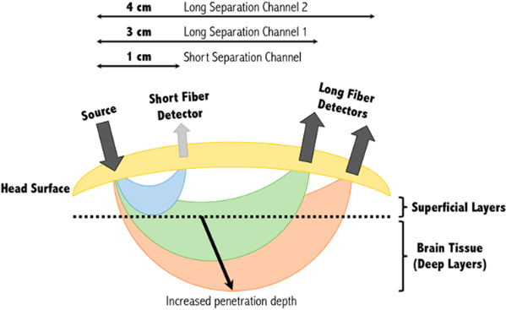

The sensor can be put on the side of the head of a newborn baby or in the front where there is little hair. However, it is important that it is not placed over the frontal sinus. Most preferred location is frontoparietal at the right or the left side. A location with abnormal blood in the skin due to trauma or a birth mark should be avoided. If necessary, clean the skin with water and dry carefully with gauze before placing the sensor.

Risk of skin marks due to heat and pressure
Since the sensor and the near-infrared light produce heat, it is recommended to review the skin below at regular intervals, at least every 12 hours. In rare cases, especially in babies with circulatory impairment and poor perfusion, the heat can cause skin burns, presenting as red skin marks – or even blisters. If the sensor is fixated too tight, the pressure from the sensor can cause skin marks as well (particularly if poor perfusion). In these situations, the location of the sensor should be revisited more often, even at 4-hours intervals. Read the user manual of the type of oximeter you use and follow the instructions.

Imprecision of measurement
When the sensor is moved, the value obtained will typically differ by 3-6%. Occasionally, the difference will be up to 10%. If the cerebral oxygenation differs markedly from the expected from the clinical condition of the baby, it may be useful to move the sensor to a new site and hold it by hand while checking the value. If necessary, this can be repeated.

The clinical meaning of cerebral oxygenation
The fact that rStO₂ largely reflect venous oxygen saturation can make the tissue oximeter a valuable supplement to the pulse oximeter.

The cerebral oxygen saturation reflects the supply/demand balance for oxygen in the brain. When the cerebral oxygenation is normal it means that the oxygen needs of the brain is met. But when the cerebral oxygenation is low – the brain is blue – its oxygen needs are not met. This usually is because the blood flow to the brain is too low. It can also be due to anaemia. Or naturally the brain will be blue if the baby is blue, due to lung or heart problems. Rarely, the brain can be blue due to epileptic seizures which causes the demand for oxygen to increase.

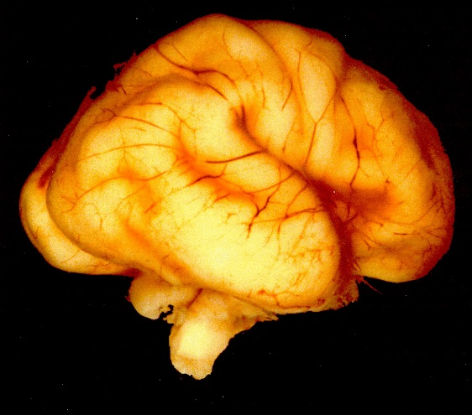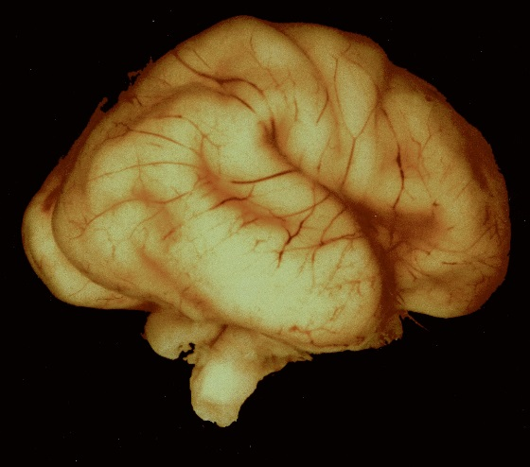
’Pink’ brain with large arteries ’Blue’ brain with small arteries

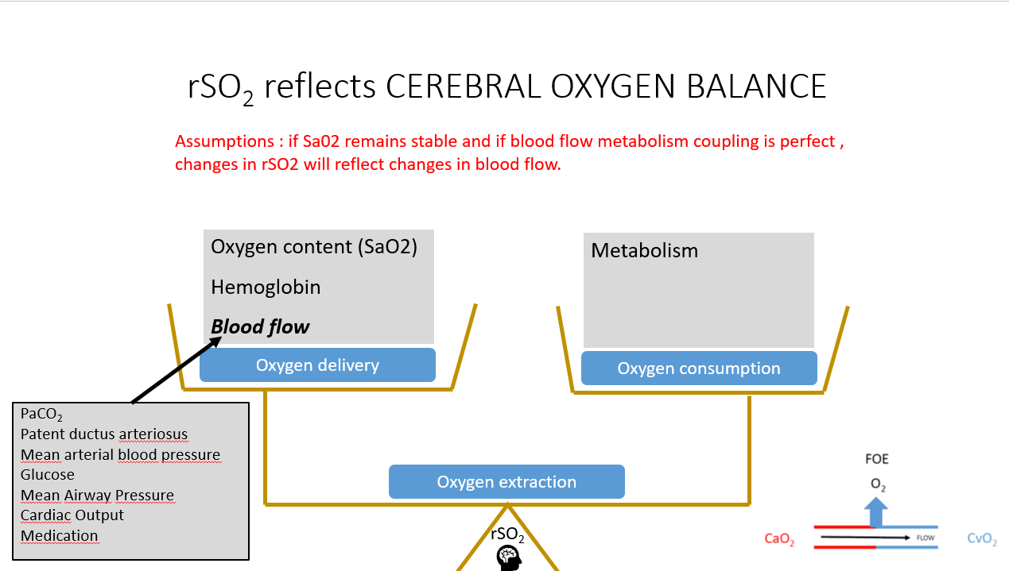
rSO₂ refers to rStO₂: tissue oxygen saturation. SaO₂ refers to SpO₂: arteriel oxygen saturation. PaCO₂: Partial arterial pressure of carbon dioxide FOE: fractional oxygen extraction. CaO₂: arterial oxygen content. CvO₂: venous oxygen content. SaO₂: arterial oxygen saturation. O₂: oxygen

Clinical case
In the following, we will take you through a clinical case, similar to those that you will meet during the quiz.

A father of a very preterm infant asks why the cerebral rStO₂ is 65, when the SpO₂ is 94. What do you tell him? Choose the correct answer.

- rStO₂ is closer to the haemoglobin oxygenation saturation in arterial than venous blood
- rStO₂ is measured in kPa, SpO₂ in percentage
- NIRS estimates the oxygen saturation of the whole blood pool a few centimeters below the skin surface, whereas pulse oximetry estimates the saturation of the arterial blood. SpO₂ will always be higher if measured correctly.

To answer this question, you must be aware of the difference between rStO₂ and SpO₂. Information regarding this can be found in the learning material under ‘Tissue oximeter differs from pulse oximeter’.

Let us go through one possibility at a time.

Option ‘1’ cannot be correct, since we know from this learning material, that the majority of blood measured by the tissue oximeter is venous. Therefore, the rStO₂ must be closer to the haemoglobin oxygenaton saturation in venous than arterial blood.

Option ‘2’ must also be wrong, since we know from the section ‘Definition’ within this learning material, that rStO₂ is a measure in percentages.

Option ‘3’, on the other hand, seems to be in line with what we have learned here in the learning material – that NIRS estimates the whole blood pool below the skin, since it is not dependent on pulsation – as is the case for pulse oximetry, which therefore only measures arterial blood. By using our clinical knowledge, we also know that the oxygen saturation is highest in arterial blood, thus will SpO₂ be higher than rStO₂.

We therefore go with option ‘3’ as the correct answer! Let us check the explanations for right and wrong here:

- Wrong. The venous blood pool is larger than the arterial and therefore influences the rStO₂ most.
- Wrong. rStO₂ is an estimate of the haemoglobin oxygen saturation of all blood below the sensor and is given in percentage.
- Correct. NIRS uses the light reflected from the tissue to estimate the oxygenation of tissue beneath the skin.

We got it right! It is cases in this format that you will meet during the quiz. Thank you for your time and good luck!

Quiz
Learning objectives
By the end of this module participants will be able to:
- Point out differences between NIRS tissue oxygenation (rStO₂) and pulse oximetry.
- Recognise consequences of rStO₂ being a direct measure of cerebral oxygen consumption/supply balance and indirect measure of cardiac output
- Know the elements in starting up NIRS monitoring and interpret values during monitoring
- Know the side effects of NIRS monitoring

Please, note that more than one answer may be right.

Questions
1. (Objective 1)
A father of a very preterm infant asks why the cerebral rStO₂ is 65, when the SpO₂ is 94. What do you tell him?
- NIRS estimates the oxygen saturation of the whole blood pool a few centimetres below the skin surface, whereas pulse oximetry only estimates the saturation of the arterial blood. Therefore, SpO₂ will always be higher if measured correctly.
- rStO₂ is closer to the haemoglobin oxygenation saturation in arterial than venous blood.
- rStO₂ is measured in kPa, SpO₂ in percentage.

Answers
- Correct. NIRS uses the light reflected from the tissue to estimate the oxygenation of tissue beneath the skin. Pulse oximetry relies on pulsation and only measures oxygenation of arterial blood. If measured correctly, SpO₂ will always be higher.
- Wrong. The venous blood pool is larger than the arterial and therefore influences the rStO₂ most. SpO₂ on the other hand, only measures on arterial blood. Thus, it will always be higher than rStO₂ if measured correctly.
- Wrong. rStO₂ is an estimate of the haemoglobin oxygen saturation of all blood below the sensor and is given in percentage.

2. (Objective 1)
A mother of an infant born 28+4 asks why her baby’s cerebral rStO₂ is only 70, when the SpO₂ is 92. What will you tell her?
- rStO₂ and SpO₂ are not related, and therefore values can differ widely.
- SpO₂ primarily reflects the lungs’ ability to oxygenate the blood, whereas rStO₂ is an estimate of the balance between oxygen delivery and consumption at tissue level. Therefore, values will always differ.
- rStO₂ and SpO₂ should measure values very close to each other. Therefore, something must be wrong with the placement of the NIRS sensor.

Answers
- Wrong. rStO₂ is determined by the oxygen delivery and consumption. The oxygen delivery is determined by the oxygen saturation in arterial blood as estimated by SpO_{2,} blood flow, and haemoglobin level. rStO₂ and SpO₂ are thus correlated – but may still differ much, since the rStO₂ depends on multiple factors.
- Correct. rStO₂ reflects the balance between oxygen delivery and consumption and the oxygen delivery changes with changes in cardiac output, among others.
- Wrong. rStO₂ is a measure of the haemoglobin oxygenation within the whole blood pool under the skin. Since most of this blood is in the veins, the rStO₂ will always measure a lower tissue oxygenation than the SpO₂, which only measures on more oxygenated arterial blood.

3. (Objective 1)
A baby is pale and mottled, and you suspect circulatory failure due to septic shock. You have a hard time getting a signal from the pulse oximeter, but the NIRS gives readings with no apparent problems. Choose the correct statement(s).
- Pulse oximetry relies on pulsating arterial blood and will be prone to error, if the circulation is poor.
- The rStO₂ should be disregarded, when the SpO₂ signal is poor,
- A decrease in rStO₂ is not a problem if the SpO₂ is normal
- NIRS measures the whole blood volume and will work irrespective of pulse.

Answers
- Correct. A pulse oximeter will not work if it does not detect pulse. NIRS however, measures the whole blood pool under the skin and is not dependent on pulsation. Therefore, it will give stable readings in situations, where the pulse oximeter cannot detect pulse.
- Wrong. A decrease in rStO₂ and a poor SpO₂ signal might be from poor perfusion of the tissue, since the pulse oximeter can have a hard time finding a signal during circulatory failure, since it is dependent on pulsation. If the pulsatile signal is poor, the pulse oximeter might even show falsely low SpO₂ values. This situation should prompt a clinical evaluation of the baby.
- Wrong. rStO₂ will drop when the cerebral blood flow decrease, since it is dependent on cerebral tissue perfusion. As opposite, the SpO₂ is primarily determined by the lungs ability to oxygenate the blood. However, during circulatory failure, the pulse oximeter may not be able to detect a signal and thus, provide falsely low values if the pulsatile signal is compromised.
- Correct. NIRS is a volume-weighted average of the saturation of the whole blood, and does not depend on pulsation, in contrast to the pulse oximeter. The arterial to venous volume ratio is 1:3, thus rStO₂ is closest to the venous saturation.

4. (Objective 2)
A tiny infant is accidently extubated and the SpO₂ drops to from 95% to 75%. Meanwhile the rStO₂ only drops from 70% to 60%. The attending doctor thinks the NIRS might be wrong. What do you tell him?
- The NIRS must be wrong as rStO₂ should at least drop as much as the SpO₂
- If blood flow increases during the desaturation in arterial blood, the rStO₂ will decrease less than the SpO₂. This compensatory mechanism must be the explanation.
- The attending doctor is correct. The rStO₂ reading must be an error.
- If the difference between SpO₂ and rStO₂ decreases, it is likely due to an increase in blood flow.
- That NIRS can only be trusted when the SpO₂ is within normal range.

Answers
- Wrong. NIRS is related to blood flow and an arterial desaturation will likely cause a compensatory increase in blood flow. Therefore, the decrease in rStO₂ will be less than that of SpO_{2.}
- Correct. When the arterial oxygen content changes, the compensatory change in blood flow will reduce the effect on the rStO₂
- Wrong. NIRS is related to blood flow and an arterial desaturation will likely cause a compensatory increase in blood flow, which will reduce the decrease in rStO₂. Therefore, a smaller rStO₂ than SpO₂ decrease is expected.
- Correct. The difference between SpO₂ and rStO₂ is correlated to the oxygen extraction fraction which is less when blood flow is high. This means that an increase in blood flow would lower the fraction of oxygen used by the tissue, thereby increasing rStO2. This would not change SpO₂ since this is dependent of pulsatile blood flow.
- Wrong. The reliability of rStO₂ is not dependent on the level of SpO_{2.}

5. (objective 2)
A colleague asks for help to understand what rStO₂ really measures. Which of the following statements would you include in your explanation.
  - rStO₂ is closer to the haemoglobin oxygenation saturation in arterial than in venous blood
  - rStO₂ is measured in kPa
  - rStO₂ may change with changes in cardiac output
  - rStO₂ will change with SpO₂, when everything else is stable

Answers
- Wrong. The venous blood pool is larger than the arterial and therefore influences the rStO₂ most.
- Wrong. rStO₂ is an estimate of the haemoglobin oxygen saturation in the tissue and is given in percentage.
- Correct. When cardiac output changes, then blood flow to all organs change. If there is no redistribution of blood flow, then cerebral blood flow will change with cardiac output, and since cerebral blood flow is a determinant of oxygen delivery to the brain this will affect rStO₂
- Correct. SpO₂ is also a determinant of oxygen delivery – although within the optimal range of SpO₂ of 90-95%, the changes in oxygen delivery are relatively small.

6. (objective 2)
You care for a baby in the experimental group on the first day of life. Everything has been stable, when the rStO2 alarm goes off and shows cerebral hypoxia. No other monitors are alarming. The ventilator runs normally, the SpO₂ is stable around 92%, and the mean arterial blood pressure is stable within normal range. As you look into the incubator to check the cerebral oximeter sensor you see that he has been bleeding from the umbilicus. It is a large spot on the linen and into the diaper and you estimate that the volume may be above 10 mL. Could that be the explanation for the cerebral hypoxia?
- No, the SpO₂ is normal
- No, the blood pressure is normal and unchanged
- Yes, the blood loss has caused anaemia, which has reduced the blood’s oxygen carrying capacity and therefore compromised the oxygen content and the oxygen delivery to the brain.
- Yes, the blood volume loss may have reduced cardiac output, and the baby has constricted its arteries to maintain the blood pressure.

Answers
- Wrong. SpO₂ and rStO₂ does not measure the same. SpO₂ measures arterial oxygen saturation, while cerebral rStO₂ is a measure of the oxygen supply/demand balance in the brain. The rStO₂ is affected by multiple factors such as cardiac output. In this case, it is plausible that the blood loss has caused a drop in cardiac output, but the blood pressure remains normal due to compensatory arterial constriction. In such a situation, rStO₂ will drop due to reduced cerebral blood flow.
- Wrong. Although arterial blood pressure is a determinant of cerebral blood flow, rStO₂ is also influenced by other factors such as cardiac output. In this case, it is plausible that the blood loss has caused a drop in cardiac output, but the blood pressure remains normal due to compensatory arterial constriction. In such a situation, rStO₂ will drop due to reduced cerebral blood flow.
- Wrong. It is unlikely that time has been sufficient for anaemia to develop
- Correct. A large, acute blood loss will cause hypovolemia and a drop in cardiac output. Vasoconstriction is the immediate reaction to this stress. In very preterm infants, this vasoconstriction also happens in the brain, thereby causing a drop in cerebral blood flow and rStO₂.

7. (Objective 3)
You move the sensor to the other side of the forehead of a sick preterm infant as part of routine care. The parents notice that rStO₂ is about 7 percentage points higher in the new position. Which answers can you give them?

- It is normal for the two sides of the brain to differ in tissue oxygenation.
- The new sensor position is probably better, as the rStO₂ is higher.
- It is normal that the rStO₂ change somewhat when the sensor is repositioned due to local differences in hair, skin, larger blood vessels, and cerebrospinal fluid.
- It must be caused by an increase in cerebral blood flow
- We tolerate a difference of about 10 percentage points between two sensor positions.

Answers
  - Wrong. There is normally no difference in the true oxygenation between different regions of the brain. However, the repeatability of rStO₂ is not perfect. Therefore, repositioning of the sensor can result in different rStO₂ values on the oximeter, despite stable ‘true’ cerebral tissue oxygenation.
  - Wrong. It is not possible to know which sensor position is most correct. Changes in the shown rStO₂ values are expected when repositioning the sensor, due to imperfect repeatability.
  - Correct. The repeatability of rStO₂ is not perfect, so a difference is expected when the sensor is re-positioned.
- Wrong. A sudden increase in cerebral blood flow is unlikely.
- Correct. Only If the rStO₂ differs more than 10 percentage when re-positioned it should prompt a new re-positioning. The repeatability of rStO₂ is imperfect, thus, different values can be expected when repositioning the sensor.

8. (objective 3)
rStO₂ drops suddenly to 40%. What would you do? Please, prioritize the following actions from first to last
- Reposition the sensor to get an impression of the rStO₂ at different location
- Look at the treatment guideline to choose at clinical intervention aimed at increasing the rStO₂
- Ensure that the sensor is in good contact with the skin
- Take a quick look at all other measure physiological parameters to possible identify a likely explanation

Answers
The actions listed above should be prioritized as 4, 3, 1, 2. It is important to react quickly if the rStO₂ drops in relation to some other clinical event, e.g., a drop in SpO_{2.} If this is the case, a prompt reaction should follow. If that is not the case, and it is only rStO₂ that drops, one should ensure that the sensor is well in contact with the skin. If it seems in good contact, the next step would be to try repositioning the sensor, to see if the low numbers can be reproduced. This may not be necessary if the decline in rStO₂ has happened over some time and a definite trend has been identified. If repositioning does not change the decline in rStO₂, the treatment guideline should be evaluated, to intervene clinically as the low rStO₂ reflects hypoxic brain tissue.

9. (objective 3)
You have to start up monitoring cerebral oxygenation. Please prioritize the following actions in the right order.
- Choose a neonatal sensor
- Clean the skin with water and dry carefully with a gauze
- Place the sensor with the light source facing towards the skin
- Take care that the light sources as well as the detectors are in good contact with the skin
- If the sensor is not self-adhesive, then use an elastic bandage to fix it, avoid the bandage being too tight.

Answers
The actions listed above should be prioritized as 1, 2, 3, 4, 5. It is important to use a neonatal sensor, as these are CE-marked for use in newborns. NB! When choosing an area, avoid areas with visible blood in the skin, and one with minimum hair. The sensor will position better, if the skin is carefully cleaned with water and dried with gauze, before application. If you do not place the sensor with light-source towards the skin, it will have no effect. Some devices will even give you a rStO₂ value, despite not facing inwards. Many sensors are not self-adhesive, and if this is the case, an elastic band should be used to fixate the sensor to the head.

10. (objective 4)
The parents ask if there are side effects to the near-infrared light used by the oximeter. Which of the following statements is false?
- The near-infrared light from the oximeter does go into the brain but most is absorbed in the skin and scalp. Less than one millionth of the light that is sent into the skin is received by the sensor.
- It increases the temperature in the brain a few degrees centigrade
- It can cause red marks on the skin due to heat
- In rare case the red marks on the skin can turn into burns – like blisters in a sunburn.
- The risk of skin marks can be reduced by moving the sensor at regular time intervals in infants at risk, i.e. infants with poor skin perfusion (blood circulation in the skin).

Answers
- This is a true statement. While visible light is reflected or absorbed in the surface (that is why we see the surface of objects and cannot see the interior), heat radiation can go deeper, which is the case for the near-infrared light sent by the oximeter. However, this penetration of light into the brain, does not affect it in any way.
- This is the false statement. The intensity of near-infrared light is reduced by 90-99% per cm of tissue it passes. As the brain is more than 5 mm from the surface and the blood circulation removes heat from the light, the temperature increase in the brain is insignificant.
- This is a true statement. If the sensor stays too long at the same place, it is possible that skin marks can occur – as if you touched a hot pan or got a sunburn.
- This is a true statement. As touching a hot pan or getting sunburn
- This is a true statement. Blood that is flowing through the skin can ‘cool’ the heated skin. The risk of skin marks is higher in babies with circulatory problems, or if there is too much pressure on the sensor, e.g. if the elastic bandage is too tight.

11. (objective 4)
The parents ask if there are side effects to the near-infrared light used by the oximeter. Which of the following statements can be included in your explanation?
- Near-infrared light has no effects on tissue
- In rare case the red marks on the skin can turn into burns – like blisters in a sunburn.
- The risk of skin marks can be reduced by moving the sensor at regular time intervals in infants at risk, i.e. infants with poor skin perfusion (blood circulation in the skin).
- It can cause eye damage if the sensor shines directly in the eye

Answers
- Wrong. Light is electromagnetic energy and is transformed to heat when it is absorbed in tissue and will raise the temperature. Many cell functions depend on temperature, and prolonged temperatures above 41 degrees centigrade may cause injuries such as skin burns – like touching a hot pan or getting a sunburn.
- Right. As touching a hot pan or getting a sunburn
- Right. Blood that is flowing through the skin can ‘cool’ the heated skin. The risk of skin marks is higher in babies with circulatory problems, or if there is too much pressure on the sensor, e.g. if the elastic bandage is too tight.
- Wrong. The light is spreading out from the sensor, so already at a few centimetres distance it is too weak to cause any eye damage

12. (objective 4)
You take over the care for a baby in the SafeBoosC-IIIv trial. He is in the experimental group. Gestational age is 29 weeks, and he is mechanically ventilated with high pressures and on high dose pressor (dopamine 10 microgram/kg/min) and yet the mean arterial blood pressure is 29 mmHg, only. The situation, however, has been stable for the last 12 hrs. The cerebral oximeter seems to work well and the rStO₂ is 65% (the hypoxic threshold of your oximeter is 58%). What will you do? Choose the correct option(s).

- Nothing. Leave the infant undisturbed.
- Check the oximeter sensor and if it sits well leave it there
- Check when the sensor was moved last time and check if that left any skin mark
- If the sensor has caused skin marks and more than 4 hours has passed in its present location, then move it.
- Move the sensor any how

Answers
- Wrong. The infant is at high risk of skin marks because of respiratory and circulatory compromise
- Wrong. Skin marks come directly under the LED (source of light) and cannot be seen unless you remove the sensor.
- Right. In this stable situation it makes sense to consider if there has been a problem with skin marks before. If not, it is reasonable to avoid the disturbance caused by moving the sensor.
- Right. In this stable situation it makes sense to consider if there has been a problem with skin marks before. If not, it is reasonable to avoid the disturbance caused by moving the sensor.
- Wrong. It may not be necessary.

13. (Objective 4)
A mother notices a minor mark on the skin of her baby, after you have moved the pulse oximeter sensor to another position. She is now concerned about the NIRS sensor as well. Which answers can you give her?
- The NIRS sensor may leave skin marks from heat or pressure.
- NIRS monitoring has no side effects.
- The heat from near infrared light penetrates deep into the tissue and may cause local brain damage
- If the sensor is not in good contact with the skin, it may give erroneous low values and result in unnecessary clinical interventions.

Answers
- Correct. NIRS monitoring can cause local skin marks due to heat and pressure. Pulse oximetry has the same risks concerning local skin damage.
- Wrong. The heat and the pressure of the sensor may cause local skin marks. It is therefore advised to reposition the sensor regularly.
- Wrong. The heat only penetrates a few millimetres, and the brain is more than five millimetres below the surface of the skin and so the NIRS sensor will not cause any damage to the brain.
- Correct. Even though heat and pressure from the sensor can cause problems it is very important to ensure that sensor is in good contact with the skin. False rStO₂ reading may lead to unnecessary and potentially harmful clinical interventions.

