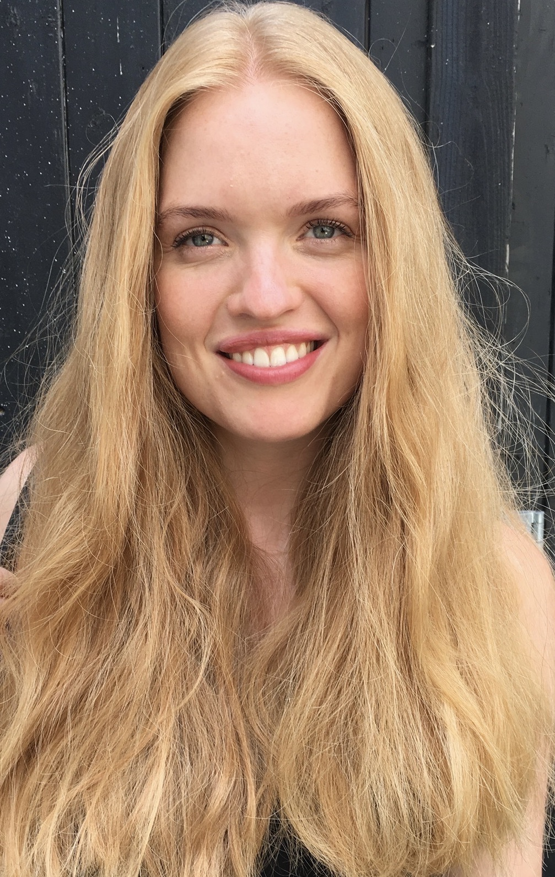

Anne Kirstine Servais Iversen (MD, PhD student)
anne.kristine.iversen@sund.ku.dk

Collects and investigates clinical samples from patients suffering from chronic wounds. Clinical findings and patient characteristics are recorded, and a range of samples (swabs, bacterial “imprints”, debridement, biopsies and tape strips) are analyzed using culturing, Fluorescence in situ hybridization (FISH), RNA-seq. and cytokine analyses. The goal is to gain a better understanding of the microenvironment in chronic wounds and prognostic factors in healing.

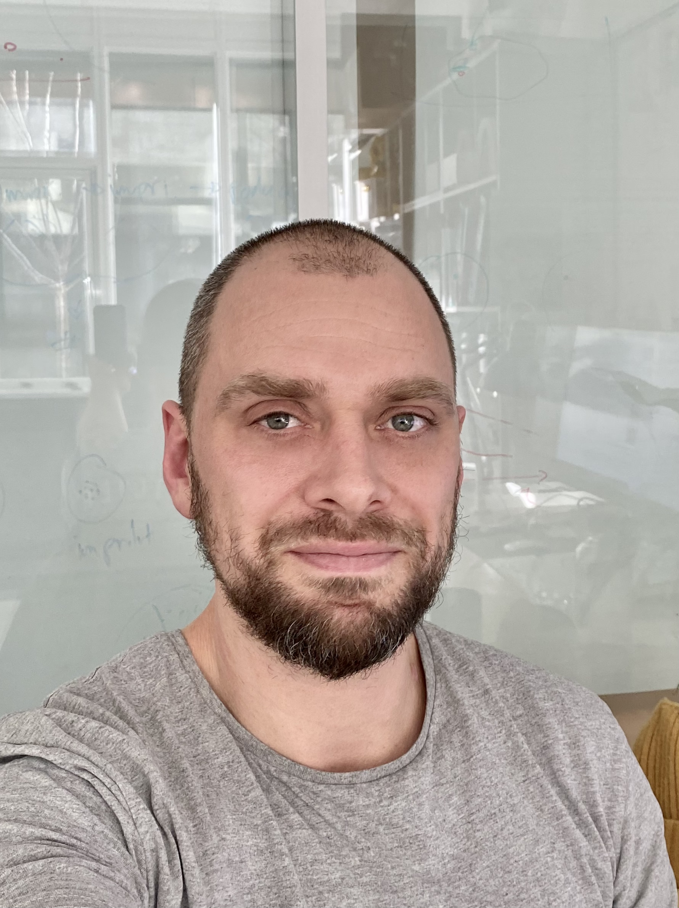

Mads Lichtenberg (Postdoc)
mlichtenberg@sund.ku.dk

Investigates the microenvironmental landscapes of chronic wound infections and the relation to bacterial physiology, metabolism, and interaction with the host. Implementation of clinical findings into chronic wound simulating in vitro models for better understanding of the behavior of clinical isolates.

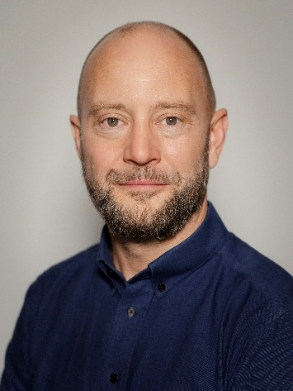
Insert photo here

Thomas Bjarnsholt (Professor, PI)
tbjarnsholt@sund.ku.dk

Head of the Bacterial Infection Biology Group at Costerton Biofilm, University of Copenhagen and co-PI of the Perfection project. Bjarnsholt focuses on the microenvironment within infections and the host-pathogen interactions.

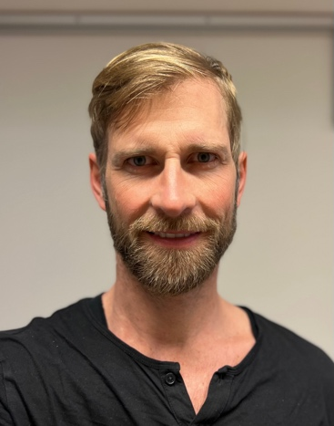

Tim Holm Jakobsen (Associate Professor)
tholm@sund.ku.dk

Studies of clinical samples for in depth investigations of host-pathogen interactions with a focus on multi-omics approaches and especially transcriptomic analysis. Using a more precise understanding of the in vivo transcriptome to increase our knowledge of biological processes in chronic wounds.

